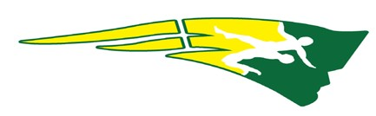

Jr. Patriots Wrestling Club
Gear Order Form

Please put the number of each item on the line provided.

T-Shirt

Youth S
M L
XL

Adult S
M L
XL
XXL

Shorts

Youth S
M L
XL

Adult S
M L
XL
XXL

Sweatshirt

Youth S
M L
XL

Adult S
M L
XL
XXL

Headgear

Youth (85 Lbs & Under) Adult (Over 85 Lbs)

Wrestler Name

